

Global carmakers could manage their costs and capital in China—and gain a strategic option for their global operations—by contracting out the manufacture of whole vehicles to Chinese companies.

Paul Gao The McKinsey Quarterly, 2002 Number 1
Faced with the prospect of stagnant global sales over the next five years, the world抯 biggest carmakers are jockeying for a share of one of the few buoyant national markets. China抯 domestic car sales, growing at more than 10 percent annually, will probably account for 15 percent of global growth over the next five years. So far, global automakers have pursued successful joint-venture strategies by investing heavily in assembly plants operated by Chinese partners. But as competition in China heats up, a new tack may be needed in the quest for profitable market share.
An asset-light strategy would have the major auto companies concentrate on what they do best—developing products and brands—while contracting out not just component supply but also the whole assembly process to Chinese automakers that can capitalize on competitive cost structures. Although scaling back capital investment in such a healthy market might seem bold, outsourcing manufacturing is neither uncommon in other industries nor entirely unprecedented in this one. Moreover, the nature of the Chinese auto industry and market makes outsourcing particularly attractive. Outsourcing might also help Chinese automakers take their first steps to becoming a global manufacturing resource. But if the strategy is to work, global carmakers must build up the skills of these Chinese partners, which in turn must embrace contract manufacturing as a more profitable path to creating a globally competitive industry than launching their own brands.
Competition is about to heat up
With sales of 2.1 million-plus units in 2000, China buys more four-wheeled vehicles than all but six other national markets, yet its passenger car market is still in the early stages of growth. Indeed China, with only 600,000 car sales a year, has fewer than 10 passenger cars on the road per 1,000 people, compared with 250 in Taiwan and more than 500 in Germany and the United States. But demand—promoted by better roads, new sales and distribution channels, the deregulation of the auto market, and China抯 entry into the World Trade Organization (WTO)—will increase as the country抯 economy continues to grow (Exhibit 1).
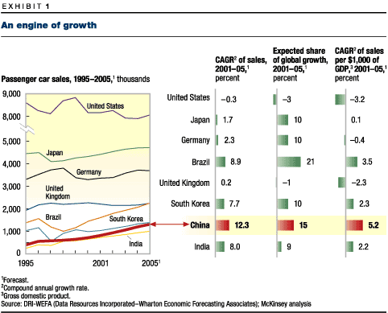
The dominant production and sales joint ventures between global and local companies have the best position for meeting that demand. Only 15 years after Volkswagen entered the market, more than half of the passenger cars sold in China roll out of VW抯 Changchun and Shanghai joint ventures. Other foreign joint ventures account for nearly all the rest—a further 43 percent (Exhibit 2). In the shadow of these foreign alliances, 20 domestic carmakers share just 3 percent of the market.
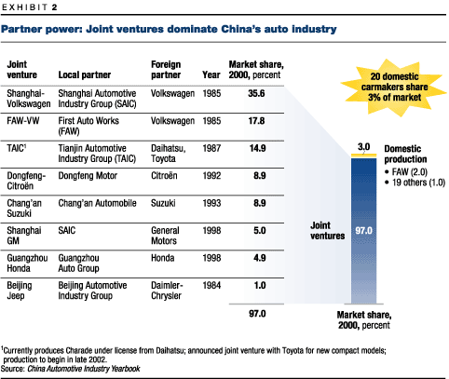
As global companies focus more and more on China, local manufacturers will do well to hold even that meager share; they concede too much ground in R&D, product development, and sales and marketing. In addition, DaimlerChrysler, GM, and VW plan to expand; Ford Motor has set up the company抯 first passenger car joint venture; and BMW has announced that it is discussing with Brilliance China Automotive the possibility that the Chinese company might assemble its 3-series and 5-series models in China.
What is more, these global carmakers are planning, for the first time, to introduce new models and upgrades in China within months of their launch in more mature markets. This development will surely end the reign of the VW Santana, a 1970s-era model that has long been out of production elsewhere but, offered without even a facelift for over 15 years, is China抯 best-selling car. China抯 entry into the WTO will cut import tariffs drastically, heightening pressure on local producers (Exhibit 3). It will also allow global carmakers to own businesses in which they have unmatchable advantages: sales, service, and distribution, as well as loan services to car buyers—services that are sure to be welcome in a market where personal credit is scarce.
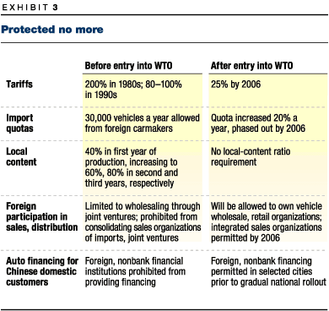
For global brands, the strategic issue is no longer whether to enter the market or how to compete with Chinese companies but rather securing or consolidating profitable market share. For Chinese automakers, this means that their ambitions will increasingly depend on the strategies of those global companies.
The need for an asset-light strategy
Competing in China involves big money: a capital investment of $1.5 billion for GM抯 Shanghai plant alone, for example, as well as $1.7 billion for the two facilities of VW抯 joint ventures. Thanks to protection of the industry, this investment has largely paid off: with tariffs ranging from 80 to 100 percent, models bear price tags up to 150 percent higher than those in the United States and Europe, allowing successful joint ventures in China to enjoy levels of profitability not seen anywhere else. For each Honda Accord, to give one example, Honda抯 Guangzhou joint venture makes over $3,000 in net profit, three times the net profit for a comparable US model.
But greater competition is already squeezing those margins. Even with technology upgrades, the list price of the standard Santana fell by 25 percent, to 115,000 ren min bi ($13,850), in the five years up to October 2001. As tariffs fall, so will prices. Meanwhile, sales and marketing costs will rise in a more competitive market, and more frequent model upgrades mean that heavier investment will constantly be needed to retool assembly plants.
This scenario—global companies stuck on a direct-investment treadmill as financial returns become more uncertain—has been played out in much of the world. China, which almost alone among new markets has its own very large auto industry, offers a point of departure. For the global carmakers, pursuing an asset-light strategy would involve contracting out the manufacture of vehicles to Chinese-owned production companies. If they can meet this demand for production, as Chinese firms have done in other industries, their global partners would reap a number of advantages.
First, the global carmakers would retain the continuing advantages of Chinese production: the ability to overcome whatever nontariff barriers to imports (such as quotas and licensing restrictions) survive China抯 entry into the WTO, as well as cheaper labor, reduced freight, and local-government concessions. And the global companies would gain these advantages with lower financial risk than they would bear if they tried to produce cars themselves.
Second, there are the direct benefits of contracting out. Global automakers in China could employ up to 40 percent less capital, which promises a corresponding 60 percent increase in their return on capital. Alternatively, contracting out would free up funds that could be concentrated on the higher-value skills of product development and design, and sales and marketing. It would also enable global companies to pursue those parts of China抯 embryonic after-sales market—retail financing, leasing, servicing, repairs, spare parts, and rentals—open to them after China抯 WTO entry. In developed markets, these activities generate 57 percent of the industry抯 profits, yet there are few established players in China (Exhibit 4).
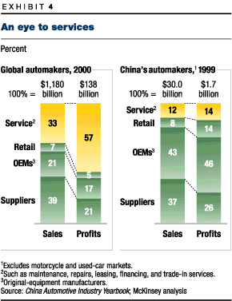
Finally, indirect benefits would flow to the global carmakers from the increased specialization and scale of the Chinese contractors, whose chief advantage is that they can develop and use their expensive technology and capacity to serve more than one customer. Given the size and automation level of the relevant assembly plants in China, doubling a plant抯 output would translate into a 5 percent savings in unit costs. Ultimately, global brands may draw on this Chinese resource to supply other markets with good-quality, competitively priced cars, which would in turn build the scale of Chinese factories to an optimal cost-reducing level.
In many ways, this asset-light strategy would mimic the success some global automakers have had with recent sales and distribution initiatives. Since mid-1999, dealers of Audi, GM, and Honda cars have invested more than $250 million in facilities and other infrastructure in China. Audi exemplified the successful implementation of this strategy when it became heavily involved in developing the sales and management skills of Chinese firms, but without investing capital in the process. The company took more than a year to select its 32 dealers, seeking entrepreneurs from the auto industry and elsewhere who were market oriented, ambitious, and able to finance their own premises and growth.
Contracting out something as fundamental as product manufacture always raises the specter of "creating your own competition." Companies that adopt the asset-light strategy naturally hope that the manufacturers they nurture won抰 eventually beat them at their own game. Although little is certain in business, global car brands can find much to allay their concerns. In the car industry, it is skills in design, brand marketing, and distribution, as well as a very few key components, notably high-performance engines, that help companies earn their competitive position. Their profits flow from sales, service, finance, and leasing. Outsourcing assembly doesn抰 force companies to transfer their skills in any of these key areas, nor should it put such advantages at risk, which is why companies like Cisco Systems, Hewlett-Packard, and IBM feel secure in outsourcing the manufacture of most of their high-end hardware systems.
Making it happen
Contracting out production isn抰 altogether novel for global carmakers: Valmet, in Finland, makes some Porsche Boxsters; Karmann, in Germany, makes convertibles for both Mercedes-Benz and VW. These successes show that, even in quality markets, customers care more about the styling, performance, and after-sales service of strong brands than about which company actually produced the car.
Moreover, successful local automakers such as SAIC (Shanghai Automotive Industry Group Corporation) are already all but contract-manufacturing for GM and VW, for the Chinese companies are totally responsible for the quality of their output, drawing on their global partners?technology and management talent as required. GM and VW, however, have invested heavily in these plants as equity partners. Contracting out manufacture requires a further degree of separation.
For contracting to succeed in China, two conditions must be met. First, the local component-supply industry will have to complete its current journey of consolidation and improved quality to meet the quantity requirements and specifications of global models. Second, global companies should continue transferring technology and management skills to selected Chinese plants.
Most global companies realize that a strong local supplier base is needed to manufacture cars at competitive cost and quality. Local components escape import duties, and though they will decline under the WTO regime, the other advantages of local production remain, particularly lower freight costs and faster supply. Competition and quality in China抯 component-supply market are already rising. Every one of the top ten global automotive suppliers had set up shop in China by the end of 2000, and many are exporting components to Europe and North America. Consolidation is being driven by China抯 shift to global models, by the tendency of Chinese companies to outsource their own component manufacturing, and by supportive government policies.
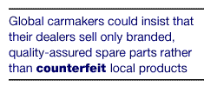
Yet global automakers could do more to help. One way would be to go on matching local capacity with international expertise, as Volkswagen has done so successfully with its joint-venture partner SAIC, its international first-tier suppliers, and the Shanghai local government, which aims to make autos a core local industry. Automakers might also insist that their dealer networks sell only branded, quality-assured spare parts rather than the counterfeit local products that now make up over 50 percent of all aftermarket supplies.
But a strong local component industry is only half of the picture, for if global automakers are to rely on local manufacturing, they will have to support efforts to increase the quality and scale of Chinese assembly plants. Further capital investment, even if available, isn抰 required; instead, the global companies can inject technology and management expertise into plants that are already being consolidated.
BMW抯 developing relationship with Brilliance China Automotive is a good example. Brilliance hired Italdesign, Giorgetto Giugiaro抯 firm, to design the company抯 proposed Zhong Hua passenger car and was building plants and training workers to manufacture it. Instead of seeing Brilliance as a competitive threat, BMW sent out its own engineers and technicians to help the Chinese company not only in building the assembly line but also in training workers, engineers, and managers in processes and quality control. If Brilliance proves itself with the Zhong Hua, BMW will give it the go-ahead to assemble the company抯 3-series and 5-series models for the East Asian market at its new Shenyang plant.
Toyota抯 relationship with Tianjin Xiali is an alternative approach to building up Chinese skills to mutual advantage. In 2000, Toyota licensed Tianjin to produce a car, marketed as a Tianjin Xiali, that was based on the Japanese Toyota Platz/Vitz compact (known as the Toyota Echo in the United States). In this way, Toyota receives revenue from the license and from car kits and components while building up Tianjin抯 abilities—all without risking the Toyota brand. Toyota also announced a joint venture with Tianjin to build an all-new model, to be sold later this year, that will bear the Toyota brand. Although Toyota Tianjin is a joint venture, the same staged approach could be taken to wholly outsourced manufacturing.
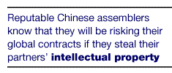
As in all such arrangements, contracts must enhance the parties?mutual dependence: the global buyer suffers if the Chinese plant can抰 meet production schedules, just as the plant suffers if the global buyer doesn抰 order sufficient volume. Global automakers will also need to protect their intellectual-property rights and product quality standards, though reputable Chinese assemblers now realize that their lucrative global manufacturing contracts will be at risk if they attempt to appropriate their partners?intellectual property or fail to meet quality standards.
The outsourcing options
For global brands with a smaller market share or a lower level of capital investment in China, asset-light manufacturing is most obviously relevant, because it gives them an opportunity to leapfrog the competition by using capital more efficiently. But the bigger players in China could also work with this strategy.
First, heretical though it may sound, proven joint-venture facilities can offer their manufacturing capacity to other brands—a strategy that has been used successfully at the GM and Toyota joint venture NUMMI (New United Motor Manufacturing Incorporated), in California, though these two companies do compete. Modern auto plants are flexible enough to make a variety of models and to switch among them quickly. There are limits to this approach, however. The collaboration between Ford and VW at Autolatina, in Brazil, came apart when both carmakers used the plant to build models that competed directly with each other rather than sticking to complementary lines.
Global automakers could also turn to contract manufacturing once local demand started to exceed the limits of their existing joint-venture capacity. In addition, they could reduce their equity in existing plants, thereby allowing the Chinese partner to take on other manufacturing contracts or the foreign partner to apply its capital to additional value-creating slivers in the automotive value chain.
In the longer term, global carmakers could develop their Chinese partners as suppliers to other markets. Global companies have already started shifting the assembly of low-end to midmarket cars to countries with a lower cost base. Even Volkswagen, with one of the most unionized labor forces in Germany, is assembling VW models in Poland, Portugal, Slovakia, and Spain. Particularly in a global downturn, serious pressure on manufacturing costs will inevitably force global players to think about China, a country where labor costs are about 1/30th those in the developed markets of Europe, Japan, and North America.
What抯 in it for Chinese automakers?
Contract manufacturing may seem a lackluster aspiration for a Chinese auto industry that has long seen its Japanese and South Korean counterparts as models of homegrown brands that became global leaders. But the conditions that underpinned the Japanese and South Korean economic models have long since disappeared. China would be helped neither by a 1970s-style oil shock (the fuel-efficient cars that propelled Japan to the forefront are now the norm) nor by the favorable exchange rate that helped South Korean brands break into low-end European and North American markets.
Moreover, insisting on self-reliance carries huge financial risks in a mature and competitive global industry. The development cost of a new mass-market car has risen to more than $1 billion, and the financial performance of most leading global automakers has long been poor. The miseries of Japan抯 once mighty Mitsubishi and Nissan and of South Korea抯 Daewoo, Hyundai, and Kia are forcing government officials and industry executives in China to rethink their policies. Despite two decades of determined reforms, none of China抯 domestic carmakers has the scale or skill to develop globally competitive new products.
By comparison, contract manufacturing can be less risky and more rewarding. Solectron, a leader in electronics-manufacturing services, outperforms its branded customers in profitability and return on investment. Auto component specialists and module suppliers around the world enjoy a higher return on capital than do the leading brands they supply. Furthermore, unlike Brazil, Britain, and Spain, where the auto assembly industries are subsidiaries of global carmakers, China has protected local ownership and can thus retain the profits the industry generates. As Chinese companies build up their manufacturing skills and capital, some might be tempted to launch their own global brands or even to purchase a financially distressed foreign brand and then rebuild that franchise, as Proton has done with Lotus. Most, however, would think twice about the prospect of risking billions of dollars to launch an untested brand and, at the same time, of losing their lucrative contract-manufacturing customers to local competitors.
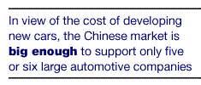
How would China抯 automakers prepare themselves for their role as contract manufacturers? Precisely as they are preparing for it today: by pursuing consolidation, productivity, quality, and the global relationships that flow from them. In the long run, given the constantly increasing expense of developing new automobiles and the sales needed to recoup it, the Chinese market is big enough to support only five or six large automotive companies—either joint ventures with strong global partners or Chinese-owned contractors. Among those likely to succeed are companies such as First Auto Works (FAW), Guangzhou Honda, SAIC, and perhaps Brilliance, which have the productivity and quality to deliver the goods that global carmakers require.
But most of China抯 domestic producers currently suffer from an inflexible manufacturing system that grossly wastes capital investment, makes production lead times lengthy and unreliable, and undermines the quality of products. The immediate need of these laggard producers is to learn from the proven production practices of the country抯 leading plants, to adopt serious lean-manufacturing initiatives, and to avoid the usual expedient of increasing capital investment whenever operational inefficiencies threaten to constrain capacity.

Since most global carmakers have had large investments in China only since 1999, it may seem odd to advocate scaling back the industry抯 capital investment now. But the nature and pace of structural reform and consumer demand in China require strategies to be reviewed constantly. As margins become tighter, producers will need strategies that both pursue market share and manage costs. To win market share, global automakers should concentrate on their new sales and distribution networks in China and on their product- and brand-development efforts around the world. To manage costs and capital, contracting out the manufacturing of whole vehicles to Chinese companies may be a leapfrog strategy for those Western carmakers that are willing to take the first steps now.
Notes:
Paul Gao is an associate principal in McKinsey抯 Shanghai office.

